LAB ASSIGNMENT-6



NAME: M Gyanada Chowdary

REG.NO: 21bce7727

COURSE: Computer Networks

SLOT: L21+22

TASK: DHCP, DNS

Configure a network and check for the connectivity and

ip addresses for DHCP and DNS protocols.

**DHCP**

Step 1:

Create a network consisting of router , Switch , 2 Pc’s , laptop and a server.

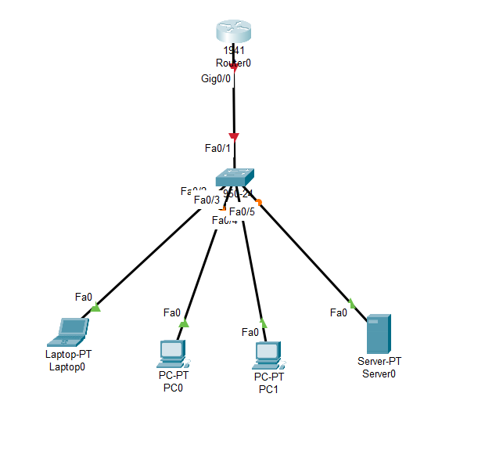

Step 2: Configure the router using CLI

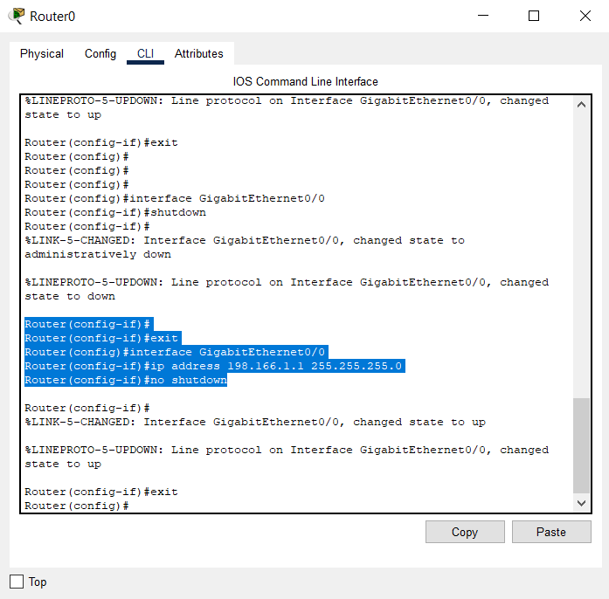

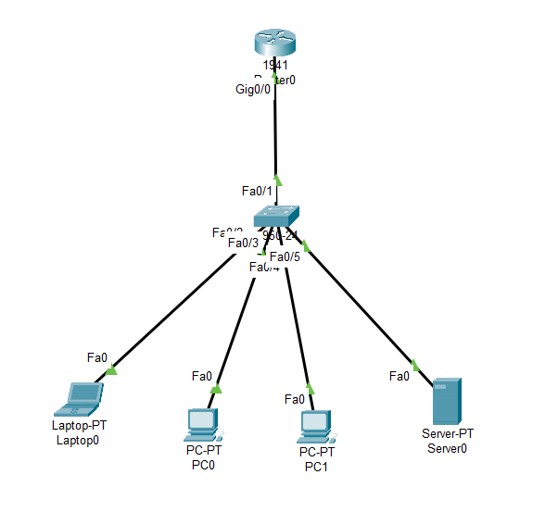

Step 3: using CLI enter into DHCP

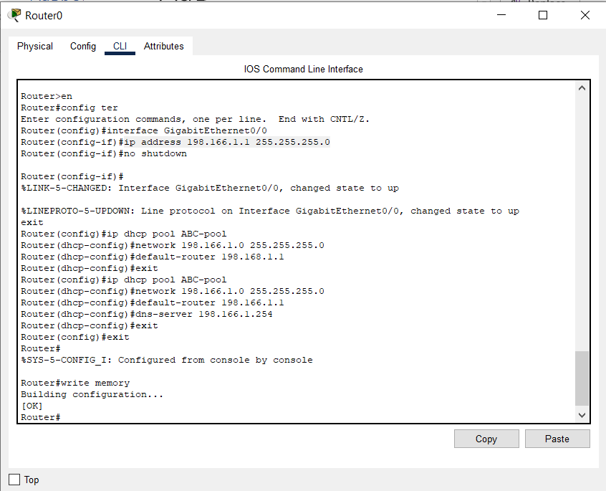

Step 4: Go to Desktop->ip configuration for each end device and

put in DHCP mode from Static mode.

For laptop0:

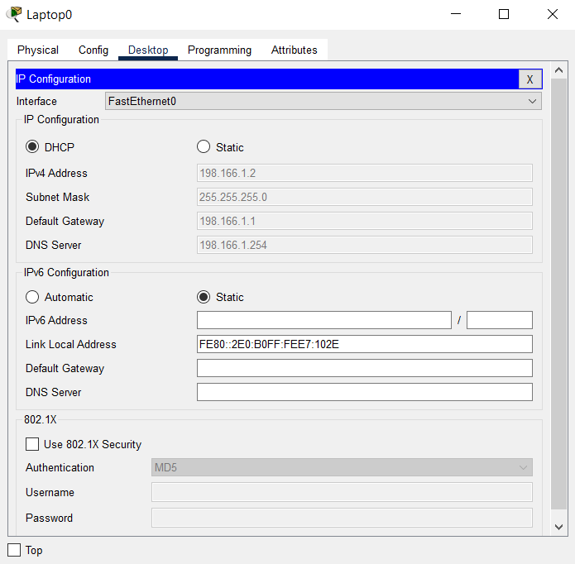

For Pc0:

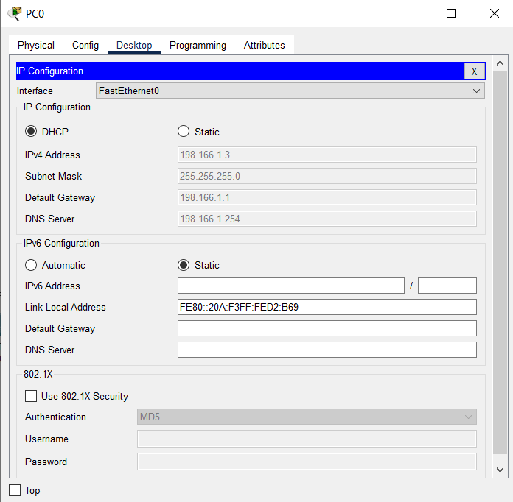

For Pc1:

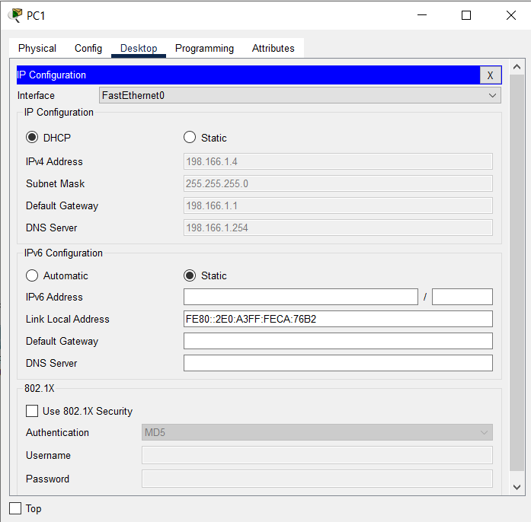

For Server0:

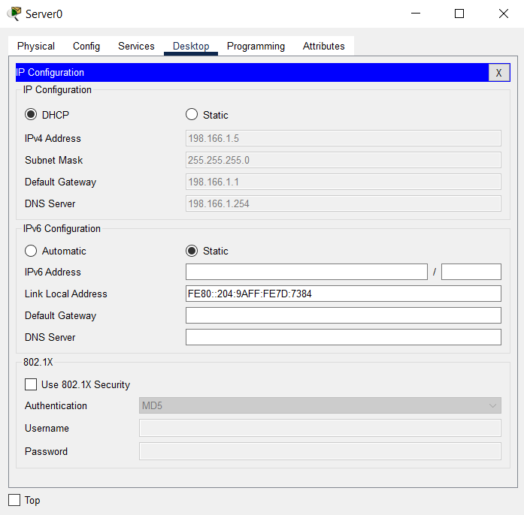

Step 5:

Take a simple PDU and check if the network is working

Source – Laptop0

Destination – PC1

1)

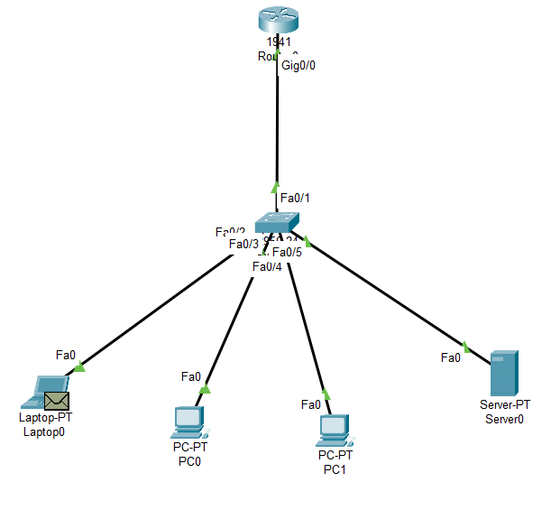

2)

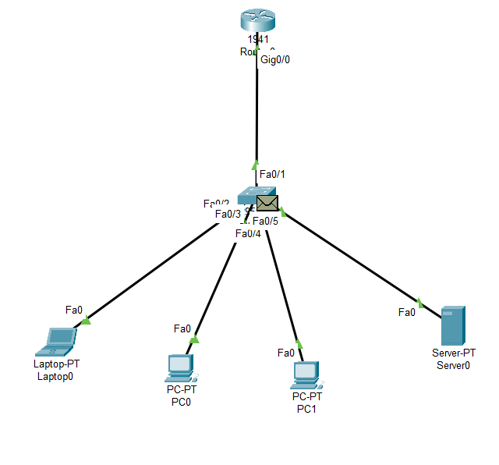

3)

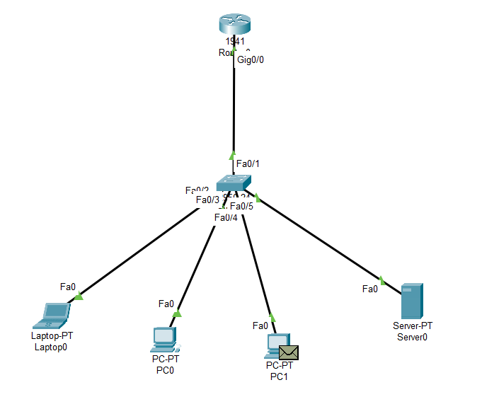

4)

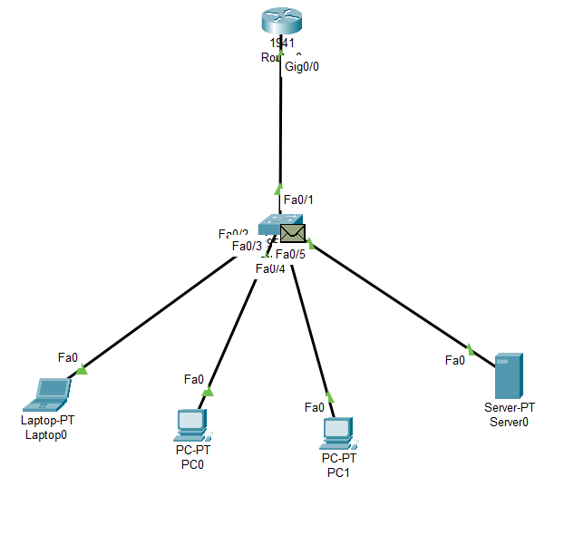

5) Final

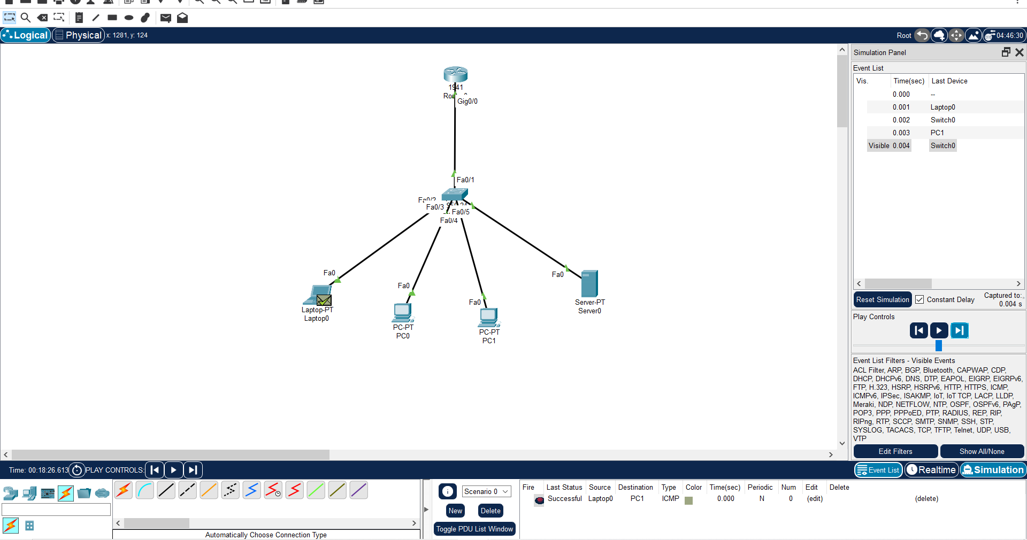

----------------------------------------------------------------------------------------------------------------------------------------------------------------------

**DNS**

Step1:

Create a network consisting of a PC, switch and a server.

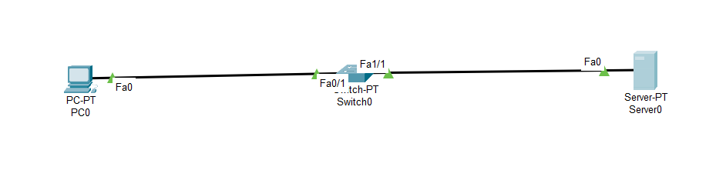

Step2:

Go to server and give ip configuration and DNS server.

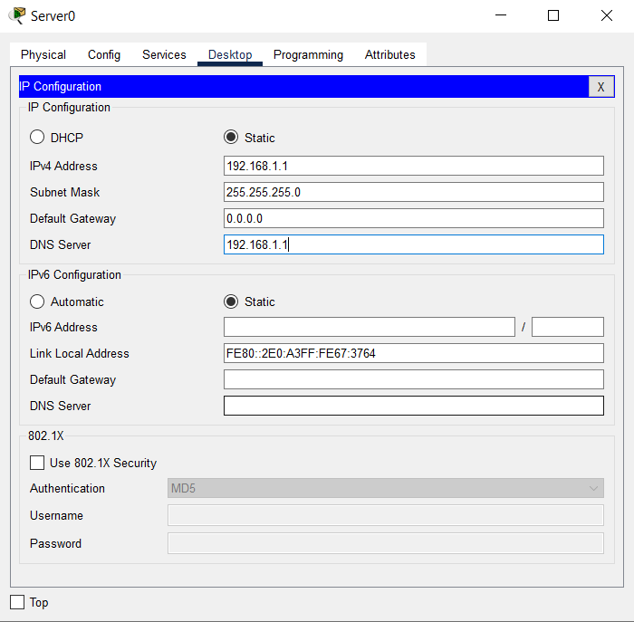

In server go to DNS interface and turn “On”

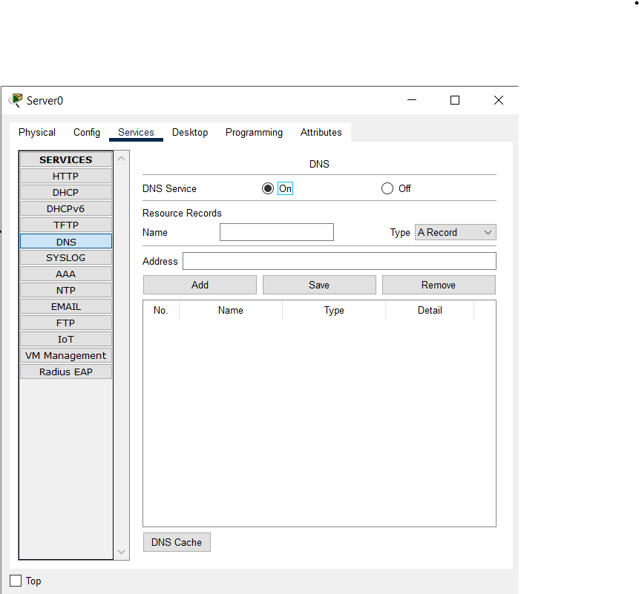

Then Go to services and Edit the “Index.html”

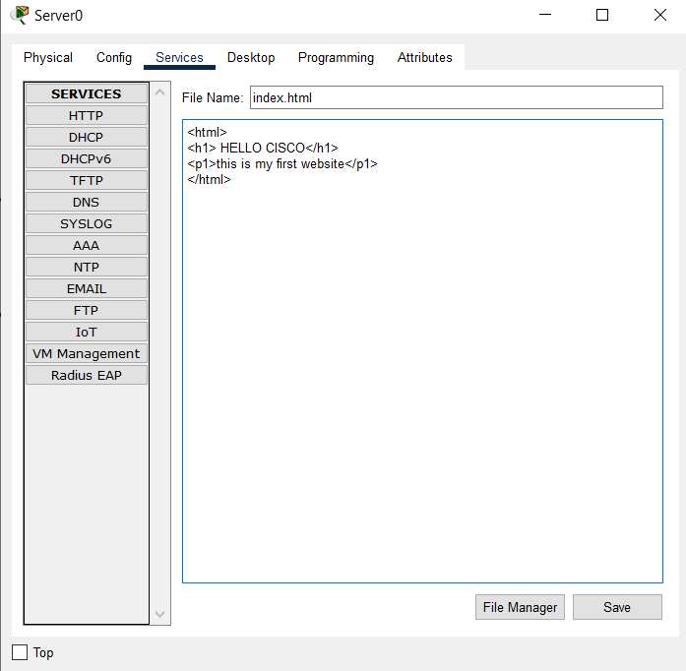

Step3: Add the server “mywebsite”

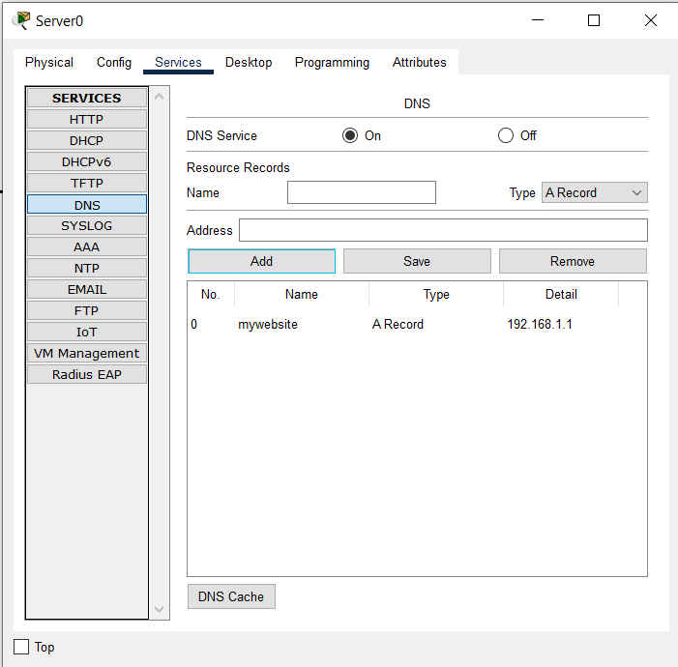

Check in PC0 ( Go to Desktop->web browser->Type “mywebsite” in

URL)

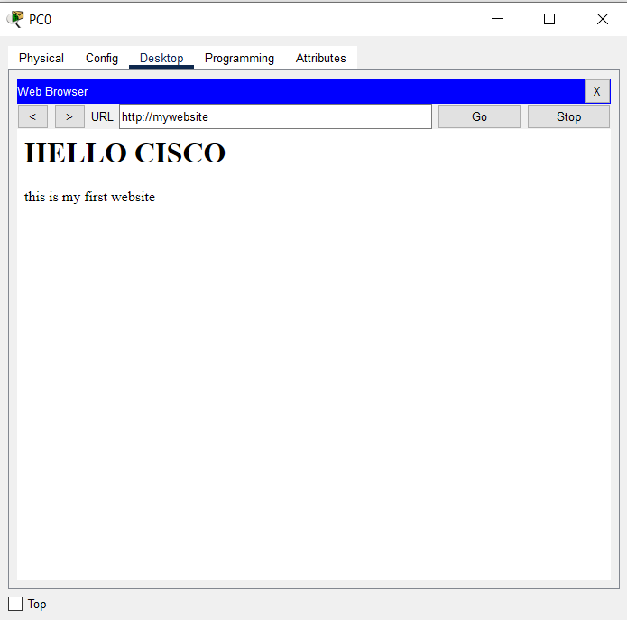

Step4:

Take another PC and give DNS and IP address

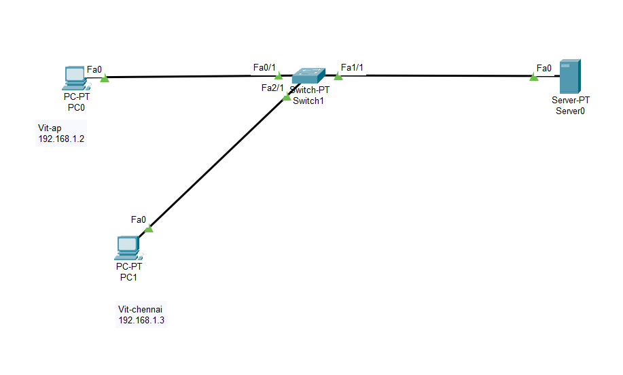

Step5:

Add the servers in DNS mode in server.

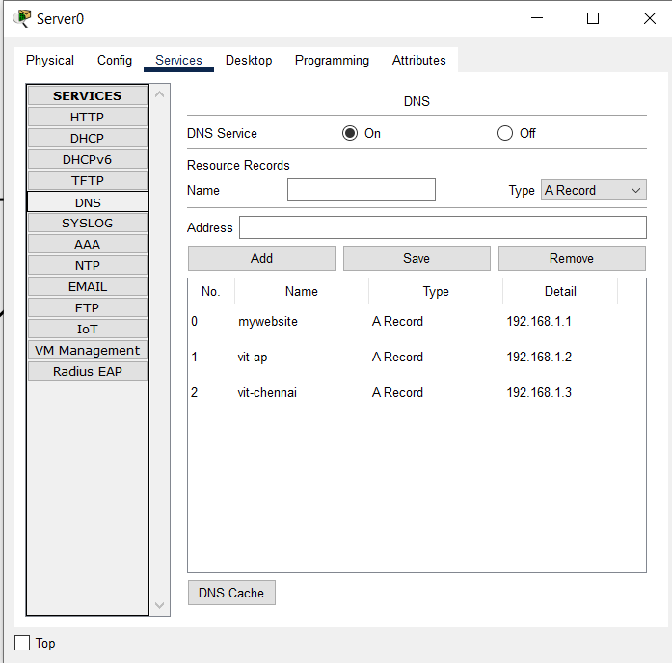

Step6:In PC (Vit-chennai) ping Vit-ap ( that is with it’s name)

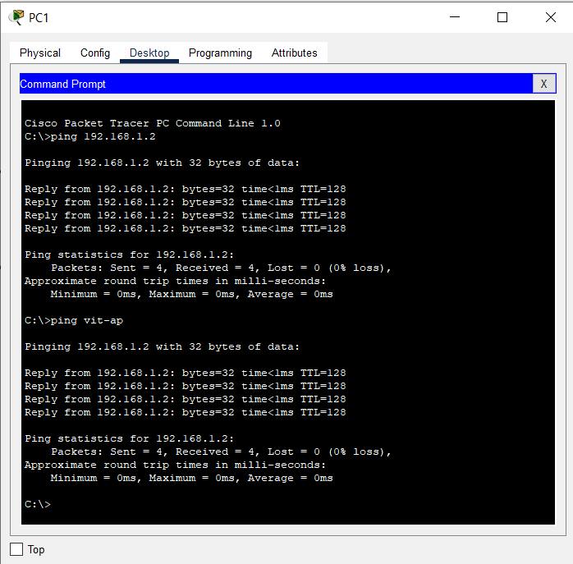

END

-------------------------------------------------------------------------------------------------------------